Quick Links
About the Project
Project Map (added to home page)
Project Goals (added to home page)
Benefits for Commuters (added to home page)
Bus Rapid Transit
Mobility Throughout the Corridor
Active CO 119 Corridor Projects (combine with Mobility throughout the corridor)
Provide Input
Prior Planning Studies (combine with Mobility throughout the corridor)
Schedule (added to home page)
Jargon (combine with Frequently Asked Questions)
Frequently Asked Questions
Document Library
Homepage:
Remove “About the Project”, so Project Overview is the first thing on the top of the page.
Rewrite Project Overview paragraph
By the year 2040, the Diagonal Highway between Boulder and Longmont is expected to see a 25% increase in vehicular traffic. Increased traffic can result in more congestion, delay, tailpipe emissions, and potentially more crashes. The Colorado Department of Transportation (CDOT) and the Regional Transportation District (RTD) are taking action to mitigate these outcomes and expand transportation options beyond private automobiles.
The CO 119 Safety and Mobility Project, a joint project between CDOT and RTD, is designing improvements to make traveling through the corridor safer for all modes and transit travel faster and more reliable. The project is designed to integrate with other active multimodal projects on the corridor to ensure community members can safely and reliably travel throughout the corridor using their mode(s) of choice. Funding has been secured for implementation of the CO 119 Safety and Mobility Project, which is expected to go to bid for construction in fall 2022.

Project Schedule
Can we add the actual project schedule graphic here? At minimum some sort of text like “Click to see the project schedule” If we can do this, we don’t need the Schedule page under Quick Links.
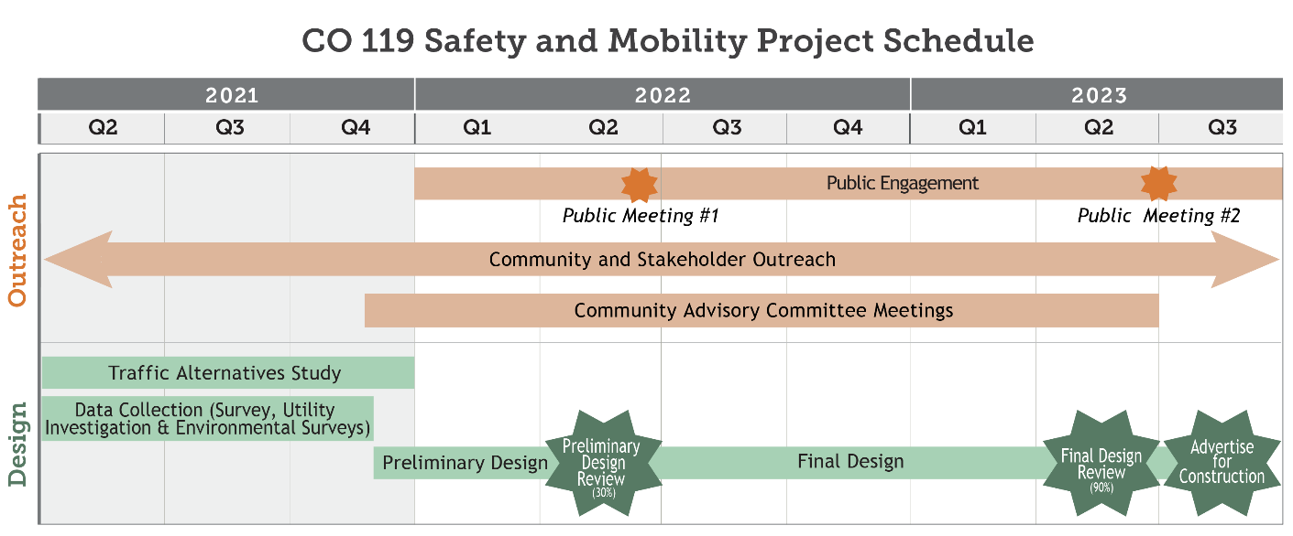

Project Area
Can we please put the project map beneath the text description.
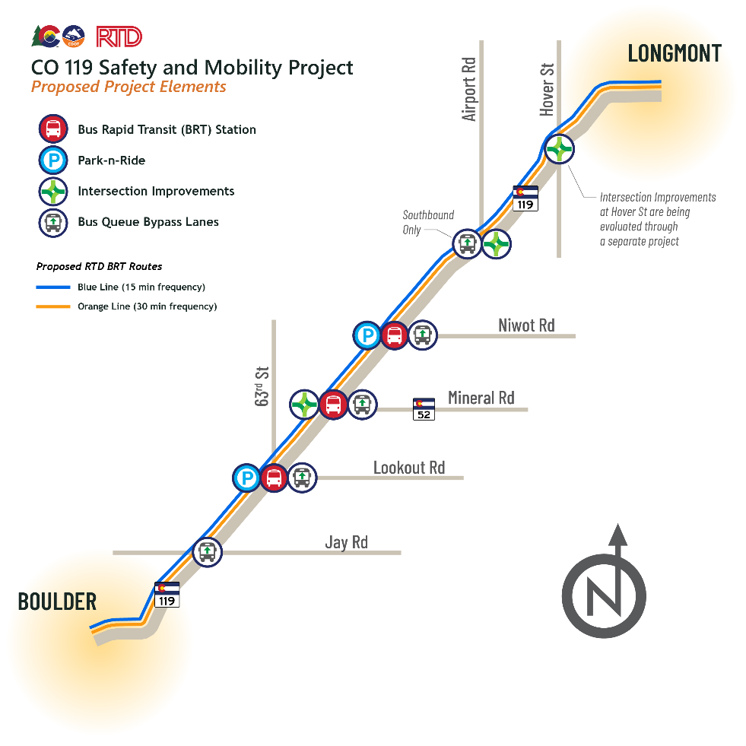
ACCORDIONS AT THE BOTTOM:
Goals
- Improve safety in the whole corridor
- Maximize intersection operational efficiency
- Maximize corridor-wide operational efficiency
- Maximize the number of people able to move through the corridor
- Improve transit travel times and increase ridership
Benefits
- Less fender benders and crashes
- Vehicles can move through the corridor faster, with shorter wait times at traffic lights
- Traveling the corridor by bus will take about half the time it currently does
- More frequent bus service supports greater travel flexibility
- Safer and more comfortable experience accessing the corridor on foot
- Integration between Bus Rapid Transit, Park-n-Rides, pedestrian crossings, and Boulder County’s Commuter Bikeway enables commuters to switch travel modes safely and reliably

Bus Rapid Transit
Please add this image beneath the text
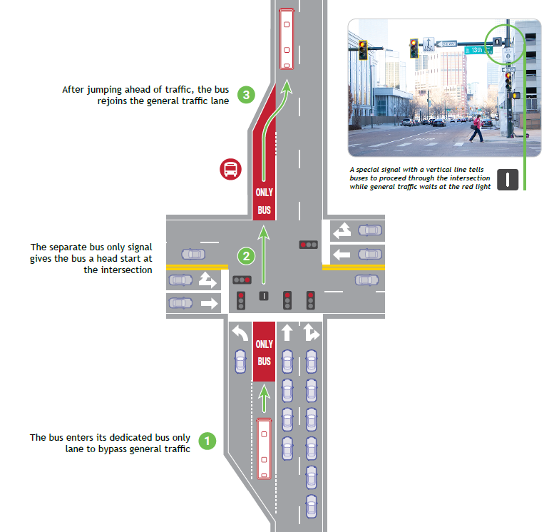

Please add this video with this text:
Watch this video to see a queue bypass signal in action.
this video

Mobility Throughout the Corridor
Northwest area stakeholders have established a multimodal vision whereby people can safely and reliably access and move throughout the corridor by walking, bicycling, riding transit, and driving. This multimodal corridor vision was established through the SH 119 Multi-Modal Planning and Environmental Linkages (PEL) Study, which identified numerous project elements being advanced as separate projects by corridor stakeholders. The CO 119 Safety and Mobility Project is being designed to integrate with these other projects:
- Boulder County Commuter Bikeway
- City of Boulder 28th Street Improvements Project
- Commuting Solutions First & Final Mile Study
- City of Longmont Coffman Street Busway
- City of Longmont CO 119 and Hover Street
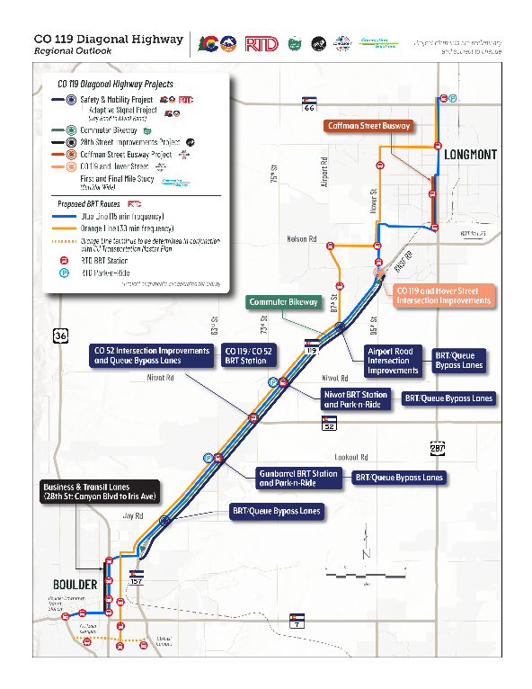
Coordination Across Projects
The CO 119 leadership structure streamlines project development so projects are advanced in an efficient and cost-effective manner. Representatives from all organizations with active planning projects on the corridor between 2020 and the present meet monthly to ensure project coordination.
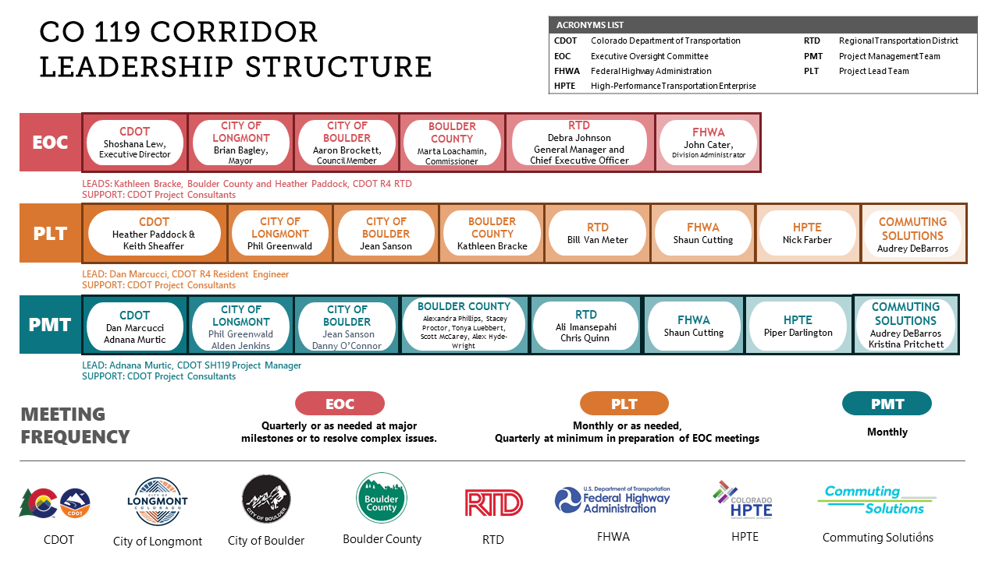
Early Planning Studies
Boulder County is one of the fastest growing areas of Colorado and area stakeholders have long advocated for improved transit to accommodate new residents and businesses. In 2014, RTD completed the Northwest Area Mobility Study (NAMS), which focused on developing consensus among RTD, CDOT, and northwest area stakeholders on cost-effective, immediate-term mobility improvements that address growing travel demand and improve mobility in the northwest region. NAMS identified the CO 119 corridor from Boulder to Longmont as a top candidate for prioritized transit service.
In 2017 RTD commissioned the SH 119 Multi-Modal Planning and Environmental Linkages (PEL) Study to implement the NAMS recommendation of optimizing regional connectivity and mobility between and within Boulder and Longmont by providing improvements that result in faster and more reliable transit travel. Whereas NAMS recommended a single Bus Rapid Transit route for the corridor, the PEL Study process determined that mobility improvements should encompass a multimodal corridor vision. To implement this vision, the PEL Study identified numerous project elements, including a commuter bikeway and first and final mile connectivity, which are currently being advanced as separate projects by corridor stakeholders.
In reviewing the PEL Study, the Federal Highway Administration and Federal Transit Administration determined that a detailed traffic analysis is necessary before design could begin on the safety and highway capacity management improvements associated with the CO 119 Safety and Mobility Project. To meet this requirement, the Colorado High Performance Traffic Enterprise (HPTE) commissioned the Traffic Alternatives Study.

Traffic Alternatives Study
A cost benefit analysis, the Traffic Alternatives study analyzed 7 highway capacity management and transit priority strategies for year 2045 conditions:
- No Build
- Baseline (intersection improvements at CO 52, Hover, and Airport)
- Queue Bypass Lanes
- 3 General Purpose Lanes
- Tolled Express Lane (adding a new lane)
- Tolled Express Lane (converting existing lane to tolled express lane)
- Tolled Express Lane (grade-separated)

Data from the traffic analysis was scored against the PEL Study goals:
- Improving safety in the whole corridor
- Maximizing intersection operational efficiency
- Maximizing corridor-wide efficiency
- Maximizing the number of people able to move through the corridor
- Improving transit travel times
- Improving connectivity to the bicycle and pedestrian network

Safety was assessed by reviewing crash improvements, pedestrian exposure, bike exposure, and intersection and segment conflict points. Cost was added as an additional scoring element. Scores were weighted for safety, operations, and cost.

Study Findings:
- Intersection Improvements and Queue Bypass Lanes tie for the highest score.
- Intersection Improvements (the Baseline) significantly improves corridor performance compared to the No-Build Alternative.
- Queue Bypass Lanes alternative is low cost and provides Bus Rapid Transit travel time savings and trip reliability.
- Tolled Express Lane Scenarios provide similar Bus Rapid Transit travel time savings and trip reliability as Queue Bypass Lanes, but at a significantly higher cost. Additionally, these scenarios increase the number of personal vehicles served in the corridor.

Recommendation:
Intersection Improvements and Queue Bypass Lanes are recommended to be advanced for design and implementation through the CO 119 Safety and Mobility Project.

Stakeholder Collaboration:
Throughout the Traffic Alternatives Study, HPTE engaged all planning partners in the corridor including Boulder County, City of Boulder, City of Longmont, Commuting Solutions, Federal Highway Administration, RTD, and CDOT. Each of the corridor planning partners provided input and helped to guide the study process. The study’s findings were reviewed and discussed by the CO 119 leadership structure. This collaborative process led to the concurrence of the recommendations by all planning partner stakeholders. This level of collaboration provides a solid foundation for the CO 119 Safety and Mobility Project to move forward to design.
Read the Traffic Alternatives Study (Missing link) report here.

Document Library
• Northwest Area Mobility Study (NAMS)
• SH 119 Multi-Modal Planning and Environmental Linkages Study (PEL)
• Traffic Alternatives Study Report
• CO 119 Safety and Mobility Project Map
• CO 119 Corridor Projects Map
• Proposed Bus Rapid Transit (BRT) Stops

